AROMA OIL DIFFUSER

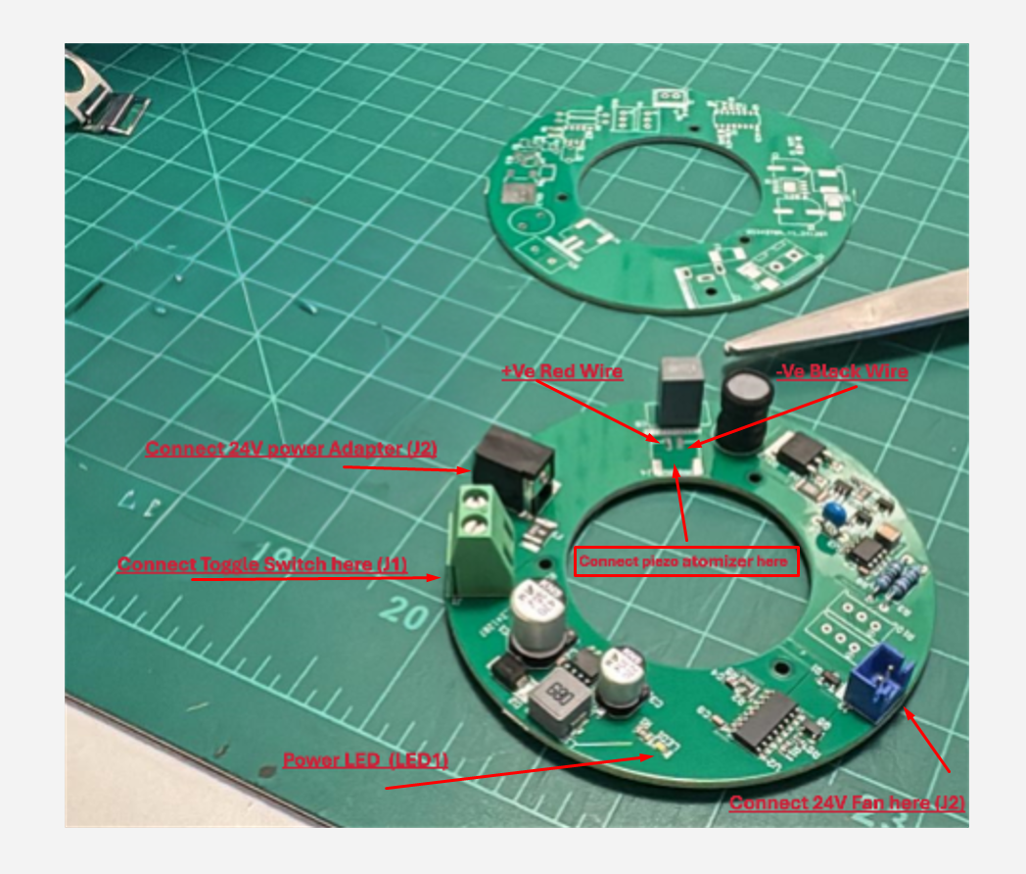

Operating instructions:
1. Cold Testing:
Before powering the PCB, perform a cold test by connecting the toggle switch wires and setting the switch to the ON position.
Using a multimeter in continuity mode:
- Place the red probe on the screw terminal's screw contacts.
- Place the black probe on the atomizer connector’s exposed pad (negative ground pad), as shown in the picture above.
If the meter does not indicate any short circuit, proceed with the steps below.

Connection Guide:
- Solder the two wires for the piezo atomizer as shown in the picture above.
- Unscrew the screws on the green screw terminal and connect the two-wire toggle switch:
  - Attach any one wire to the first terminal.
  - Attach the other wire to the second terminal.
- Connect the 24V fan to the fan connector.
- Connect the 24V power adapter to the DC barrel jack connector. Power up the board by toggling the switch to the ON position. The white LED on the board should light up, and the fan should turn ON.
- Place the atomizer disc in 0.5 inches of water. It will start creating a mist of water vapor.
Peripheral Links:
24V 2 Amp power Adapter
Toggle Switch (SPST) (On/Off)
DC 24V Blower Fan (75mm x 30mm)
D16mm 1.7MHz Ultrasonic Atomizer

